Mi Tienda de Informática

Mi Logo:

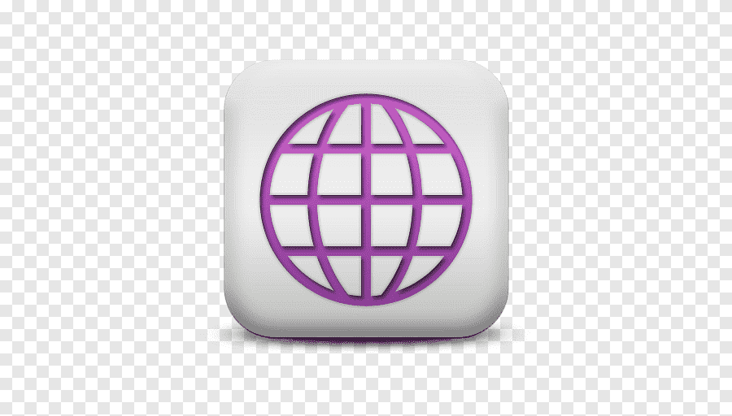

Colores:

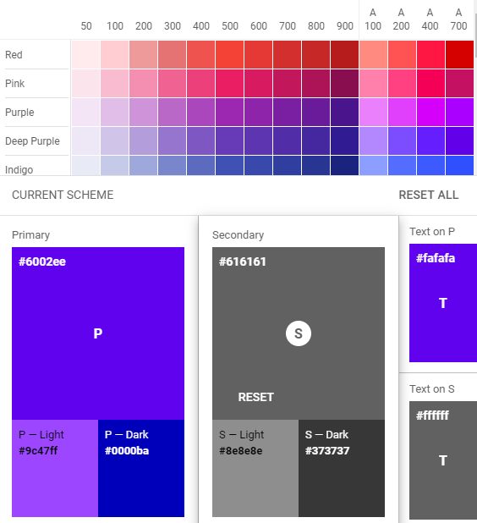

Tipografía:

|  |  |  |  |  |
| --- | --- | --- | --- | --- |
| H1 | Arial | 30px | Blanca | Central |

|  |  |  |  |  |
| --- | --- | --- | --- | --- |
| H2 | Tahona | 25px | blanca | Izquierdo |

|  |  |  |  |  |
| --- | --- | --- | --- | --- |
| H3 | Tahona | 20px | Negrita | Izquierdo |

|  |  |  |  |  |
| --- | --- | --- | --- | --- |
| H4 | Tahona | 18px | Negrita | Izquierdo |

Botones y elementos de navegación:

|  |  |
| --- | --- |
|  |  |